 | 14.3.5 Editors - Video Sequence Editor - Sidebar - Sequencer - Modifier tab

Table of content
Modifier Tab 4
General functionality 4
Add 4
Header elements 4
Collapse panel 4
Modifier Icon 4
Modifier Name 4
Mute 4
Move Strip Modifier 4
Remove Strip Modifier 4
Modifiers Panel 5
Use Linear Modifiers 5
Add Strip Modifiers 5
Copy to selected Strips 5
Workflow 5
Replace 5
Append 5
Color Balance Modifier 5
Mask Input Type 5
Mask Input Type type Strip 6
Mask 6
Mask Input Type type Mask 6
Mask 6
Mask Time 6
Relative 6
Absolute 6
Multiply Colors 6
Lift 6
Gamma 6
Gain 6
Curves Modifier 6
Mask Input Type 6
Mask 6
Tone 7
C R G B 7
Selecting Points 7
Adding Points 7
Navigation elements 7
Zoom in and out 7
Tools 7
Reset View 7
Vector Handle 7
Auto Handle 7
Auto Clamped Handle 7
Extend horizontal 8
Extend vertical 8
Reset Curve 8
Use Clipping 8
Delete Points 8
Hue Correct Modifier 8
Mask Input Type 8
Mask 8
H S V 8
Selecting Points 8
Adding Points 9
Navigation elements 9
Zoom in and out 9
Tools 9
Reset View 9
Vector Handle 9
Auto Handle 9
Auto Clamped Handle 9
Extend horizontal 9
Extend vertical 9
Reset Curve 9
Use Clipping 10
Delete Points 10
Bright / Contrast modifier 10
Mask Input Type 10
Mask 10
Bright 10
Contrast 10
Mask modifier 10
Mask Input Type 10
Mask 10
White Balance modifier 10
Mask Input Type 11
Mask 11
White Value 11
Tone map modifier 11
Mask Input Type 11
Mask 11
Tone map Type 11
Intensity 11
Contrast 11
Adaption 11
Color Correction 11
Equalizer modifier 12
Adding Points 12
Navigation elements 12
Zoom in and out 12
Clipping Options 12
Tools 12
Reset View 12
Reset Curve 12
Footer 13
Handles 13
Auto Handle 13
Vector Handle 13
Auto Clampled 13
X / Y Values 13
Delete Points 13

Modifier Tab
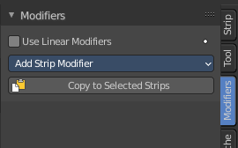
In the Modifer tab you will find strip modifiers to manipulate image content. Modifiers is a non destructive way to manipulate the data.

Note that these modifiers cannot be applied.

General functionality

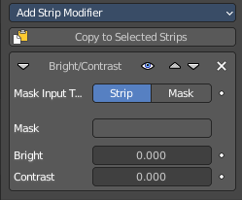
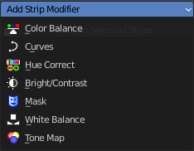
Add

To add a modifier to an object, simply open the drop down menu, and choose the type of modifier that you want to add.

This will add the modifier to the list of modifiers. Also called the modifier stack.

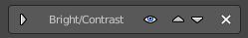
Header elements
Elements are explained from left to right.

Collapse panel
The whole modifier panel can be collapsed. Click at the arrow button up left in the header.

Modifier Icon
This icon shows the type of the modifier. And has no further functionality.

Modifier Name
The name of the modifier. You can rename modifiers by clicking into the edit field and change the text.

Mute
Don't use this modifier.

Move Strip Modifier
Move the modifier upwards or downwards in the list.

Remove Strip Modifier
Removes the modifier from the list.

Modifiers Panel

Use Linear Modifiers
Calculate modifiers in linear space instead of sequencer space.

Add Strip Modifiers
The list of available modifiers. Clicking will insert it into the modifier stack.

Copy to selected Strips
Copies the modifiers from one strip to another strip.

Workflow
Select the strip without modifier. Hold down shift, select the strip with the modifiers. Click the copy to selected button, choose the method in the popup. And the modifier should now be at the first strip.

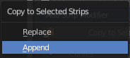
Replace
Replace the modifiers in the modifier stack of the target strip.

Append
Append the modifiers to the modifier stack of the target strip.

Color Balance Modifier

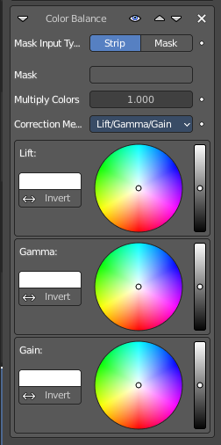
Color balance adjustments, through Lift, Gamma, and Gain.

Mask Input Type
Type of input data used for mask.

Mask Input Type type Strip

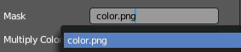
Mask
The strip used as mask input for the modifier.

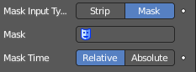
Mask Input Type type Mask

Mask
The mask used as mask input for the modifier.

Mask Time
Time to use for the mask animation.

Relative
Mask animation is offset to start of strip.

Absolute
Mask animation is in sync with scene frame.

Multiply Colors
Multiply the intensity of each pixel by this factor.

Lift
Color picker for the lift color. The panel content should be self explaining.

Gamma
Color picker for the Gamma color. The panel content should be self explaining.

Gain
Color picker for the Gain color. The panel content should be self explaining.

Curves Modifier

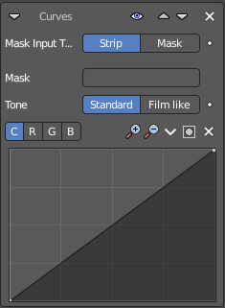
Color and RGB curves.

Mask Input Type
Type of input data used for mask.

Mask
The strip used as mask input for the modifier.

Tone
Tone mapping of the curve. Standard or film like.

C R G B
What color channels to affect. C stands for color, for all channels.


Selecting Points
You can select curve points. This reveals two edit boxes for the x and y coordinate of this point.
Selected points can be moved around. Left click at them, hold the mouse button down and move them to a new location.


Adding Points

Navigation elements
The navigation elements at the top are described from left to right.

Zoom in and out
The two buttons with the magnifying glass at it zooms in and out in the curve window.

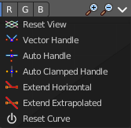
Tools
Tools is a menu where you can find some curve related tools.

Reset View
Resets the curve windows zoom.

Vector Handle
Set handle type to Vector.

Auto Handle
Set handle type to Auto.

Auto Clamped Handle
Set handle type to Auto Clamped.

Extend horizontal
Extends the curve horizontal before the first curve point and after the last curve point.

Extend vertical
Extends the curve vertical before the first curve point and after the last curve point.

Reset Curve
Resets the curve to the initial shape.


Use Clipping
Clipping options. Set up clipping for the stroke. The blue button at the top turns clipping on or off.

Delete Points
Deletes the selected curve point.

Hue Correct Modifier

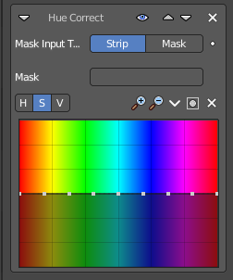
HSV multi points curves.

Mask Input Type
Type of input data used for mask.

Mask
The strip used as mask input for the modifier.

H S V
What color channels to affect. Hue, saturation, value.

Selecting Points
You can select curve points. This reveals two edit boxes for the x and y coordinate of this point.
Selected points can be moved around. Left click at them, hold the mouse button down and move them to a new location.

Adding Points

Navigation elements
The navigation elements at the top are described from left to right.

Zoom in and out
The two buttons with the magnifying glass at it zooms in and out in the curve window.

Tools
Tools is a menu where you can find some curve related tools.

Reset View
Resets the curve windows zoom.

Vector Handle
Set handle type to Vector.

Auto Handle
Set handle type to Auto.

Auto Clamped Handle
Set handle type to Auto Clamped.

Extend horizontal
Extends the curve horizontal before the first curve point and after the last curve point.

Extend vertical
Extends the curve vertical before the first curve point and after the last curve point.

Reset Curve
Resets the curve to the initial shape.

Use Clipping
Clipping options. Set up clipping for the stroke. The blue button at the top turns clipping on or off.

Delete Points
Deletes the selected curve point.

Bright / Contrast modifier

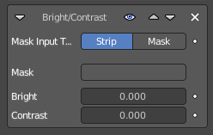
Adjusts the brightness and contrast of the modifier input.

Mask Input Type
Type of input data used for mask.

Mask
The strip used as mask input for the modifier.

Bright
Adjust the luminosity of the colors.

Contrast
Adjust the contrast of the colors.

Mask modifier

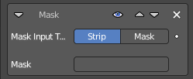
Use it for masking the other modifiers in the stack which are below.

Mask Input Type
Type of input data used for mask.

Mask
The strip used as mask input for the modifier.

White Balance modifier

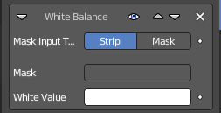
Use it to adjust the white balance by choosing the color that should be white.

Mask Input Type
Type of input data used for mask.

Mask
The strip used as mask input for the modifier.

White Value
The color that defines white in the strip.

Tone map modifier

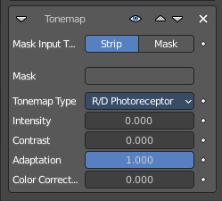
Used to map one set of colors to another in order to approximate the appearance of high dynamic range images in a medium that has a more limited dynamic range.

Mask Input Type
Type of input data used for mask.

Mask
The strip used as mask input for the modifier.

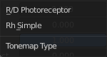
Tone map Type
What tone mapping algorithm to use.

Intensity
A value less than zero darkens the image. A value higher than zero brightens the image.

Contrast
Adjust the contrast. A value of 0 uses the input value.

Adaption
The color adaption. If 0 global, if 1 based on pixel intensity.

Color Correction
The color correction. If 0 same for all channels. If 1 each independent.

Equalizer modifier

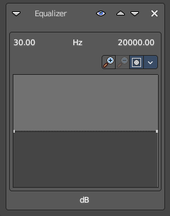
An audio equalizer for audio clips. The range goes from 30 hz to 20.000 hz

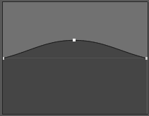
Adding Points

Navigation elements
The navigation elements at the top are described from left to right.

Zoom in and out
The two buttons with the magnifying glass at it zooms in and out in the curve window.

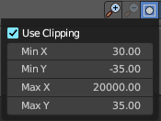
Clipping Options
Clips the values.

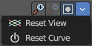
Tools

Reset View
Resets the view.

Reset Curve
Resets the curve.

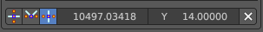
Footer
The footer contains further tools to modify the selected point

Handles

Auto Handle
Set the handle type to auto

Vector Handle
Set the handle type to vector

Auto Clampled
Set the handle type to auto clamped.

X / Y Values
The position of the selected point.

Delete Points
Removes the selected point.

